US HEADQUARTERS

525 Almanor Avenue, 4th Floor

Sunnyvale, CA 94085

+1-650-963-9828 Phone

+1-650-968-2997 Fax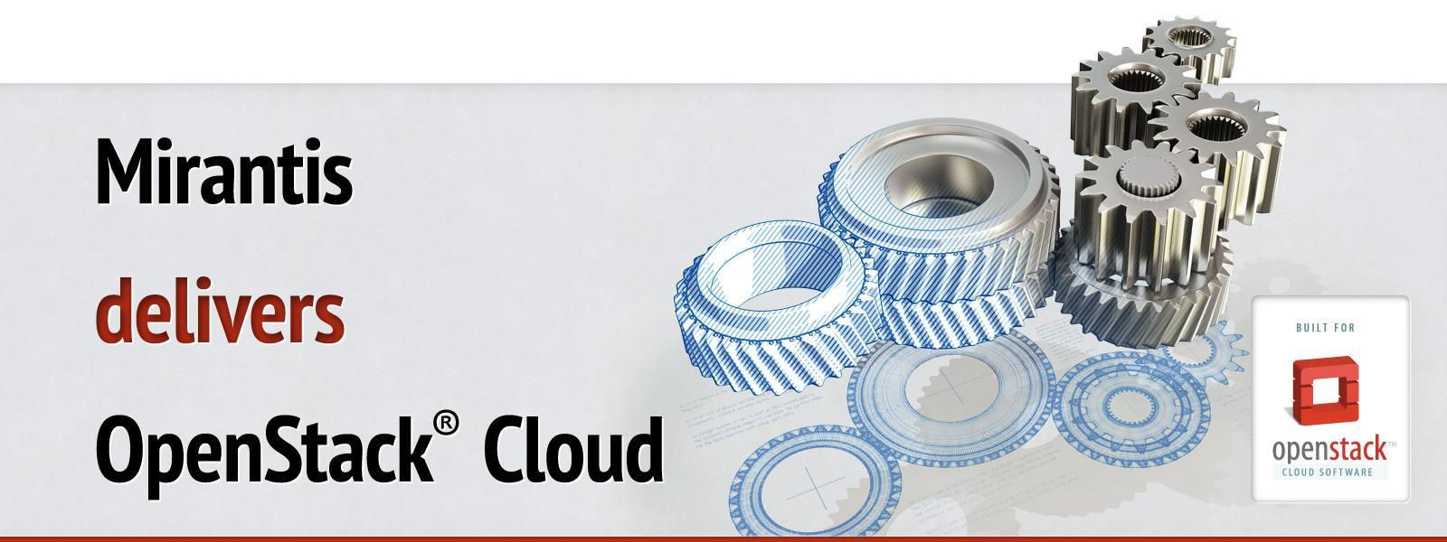

Run book for OpenStack

Deployment guide

Cluster Big Customer Staging

OpenStack Liberty

*Version 1*

*28 July, 2016*

*Author(s) <Ramon Melero, rmelero@mirantis.com>*

# Access Information

|  |  |
| --- | --- |
|  |  |
| Fuel UI Master Node URL | https://10.20.0.2:8443 |
| Fuel UI Credentials | admin / admin |
| Fuel Master Node IP | 10.20.0.2 |
| Fuel SSH Credentials | root / r00tme |
| OpenStack Nodes SSH Credentials | root / r00tme |
| OpenStack Horizon URL | 172.16.0.2 |
| OpenStack Horizon Credentials | BigUser / BigPass |

# Nodes

|  |  |  |  |  |  |
| --- | --- | --- | --- | --- | --- |
| Hostname | Role(s) | Admin network IP address | CPUxCores | RAM | HDD |
| node-1 | controller, mongo, cinder | 10.20.0.4 | 12 | 65535 MB | vda: 512GB vdb: 512GB vdc: 512GB vdd: 512GB |
| node-2 | compute, cinder | 10.20.0.6 | 12 | 65535 MB | vda: 512GB vdb: 512GB vdc: 512GB vdd: 512GB |
| node-3 | compute, cinder | 10.20.0.5 | 12 | 65535 MB | vda: 512GB vdb: 512GB vdc: 512GB vdd: 512GB |
| node-4 |  | 10.20.0.7 | 12 | 65535 MB | vda: 512GB vdb: 512GB vdc: 512GB vdd: 512GB |
| node-5 |  | 10.20.0.8 | 12 | 65535 MB | vda: 512GB vdb: 512GB vdc: 512GB vdd: 512GB |
| node-6 |  | 10.20.0.3 | 12 | 65535 MB | vda: 512GB vdb: 512GB vdc: 512GB vdd: 512GB |
| node-7 |  | 10.20.0.9 | 12 | 65535 MB | vda: 512GB vdb: 512GB vdc: 512GB vdd: 512GB |
| node-8 |  | 10.20.0.10 | 12 | 65535 MB | vda: 512GB vdb: 512GB vdc: 512GB vdd: 512GB |
| node-9 |  | 10.20.0.11 | 12 | 65535 MB | vda: 512GB vdb: 512GB vdc: 512GB vdd: 512GB |

# Support Information

|  |  |
| --- | --- |
|  |  |
| Customer Name | Big Customer |
| Environment ID | 69a536ec-79d0-47cc-ae99-84af8a76201d |
| Support Entitlement Package | 24 x 7 |
| Days of Direct Support | 24 x 7 |
| Hours of Direct Support | 24 x 7 |
| Support Timezone | America/Central |
| Support Phone Numbers | (512) 555-5555, (512) 666-6666 |
| Support Email | support@mirantis.com |
| Support Website | https://mirantis.my.salesforce.com/ |
| Severity 1 SLA | 15 Minutes |
| Severity 2 SLA | 1 Business Hour |
| Severity 3 SLA | 4 Business Hours |
| Severity 4 SLA | 8 Business Hours |
| Customer Success Manager | Customer Success Manager, mystuffisbroken@mirantis.com |

# Network Layout - Environment 1

|  |  |  |  |  |
| --- | --- | --- | --- | --- |
| Network name | Speed | Port mode | IP Range | VLAN |
| public | None | (no data) | 172.16.0.0/24 | Native |
| management | None | (no data) | 192.168.0.0/24 | 101 |
| storage | None | (no data) | 192.168.1.0/24 | 102 |
| private | None | (no data) | None | Native |
| fuelweb_admin | None | (no data) | 10.20.0.0/24 | Native |

# Environments

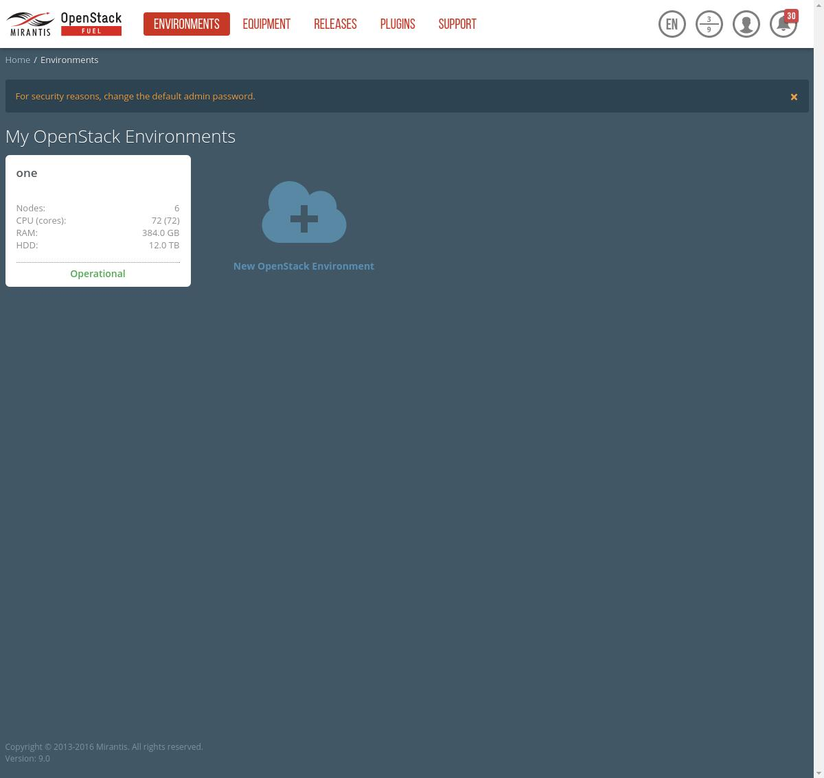

# Equipment_0

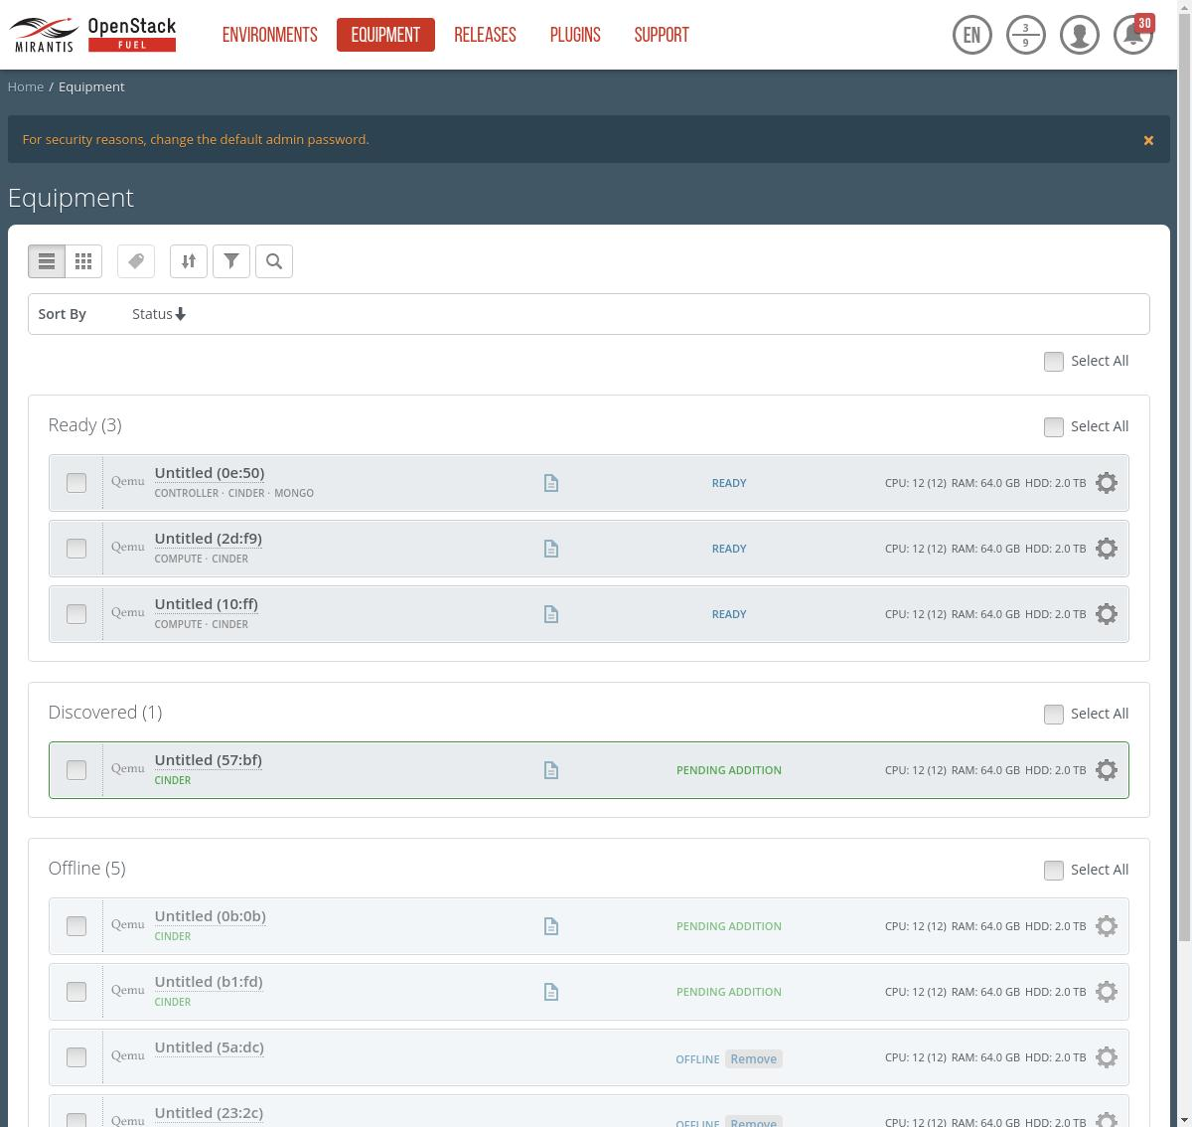

# Equipment_1

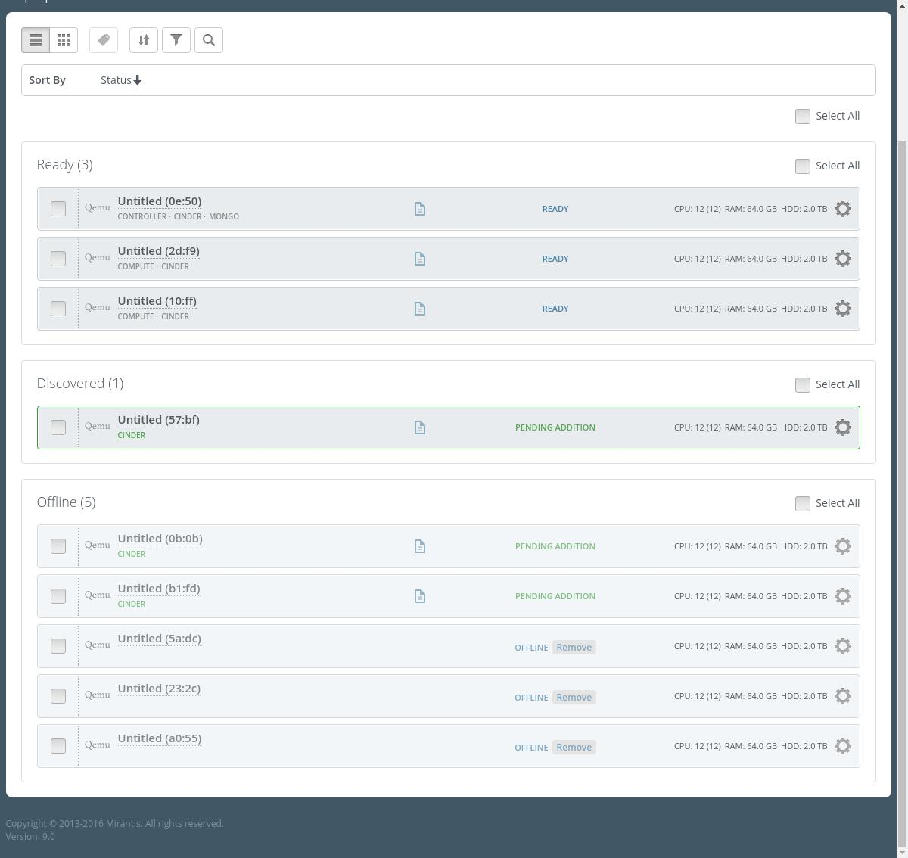

# Releases

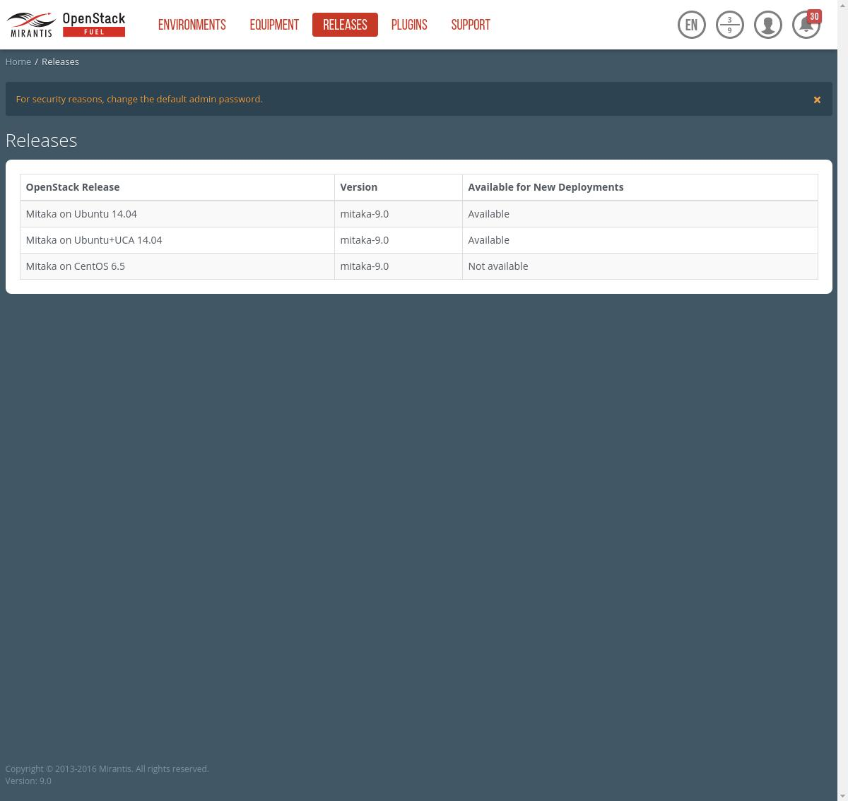

# Plugins

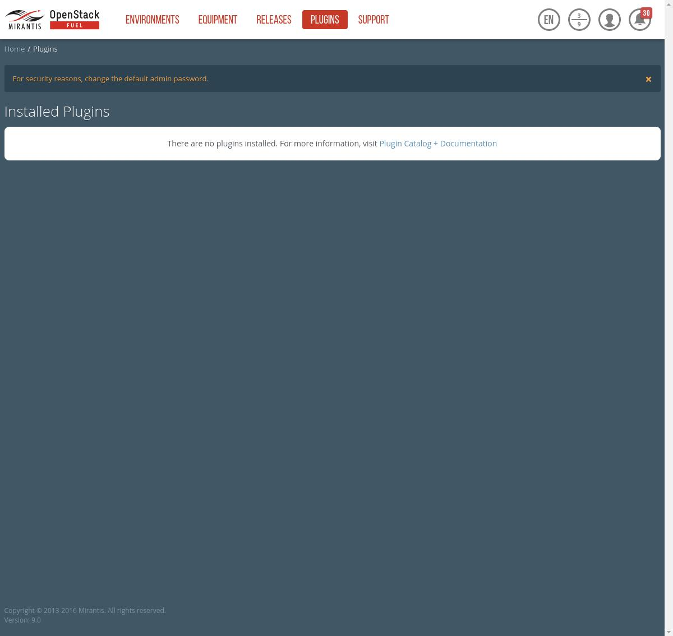

# env_1_dashboard_0

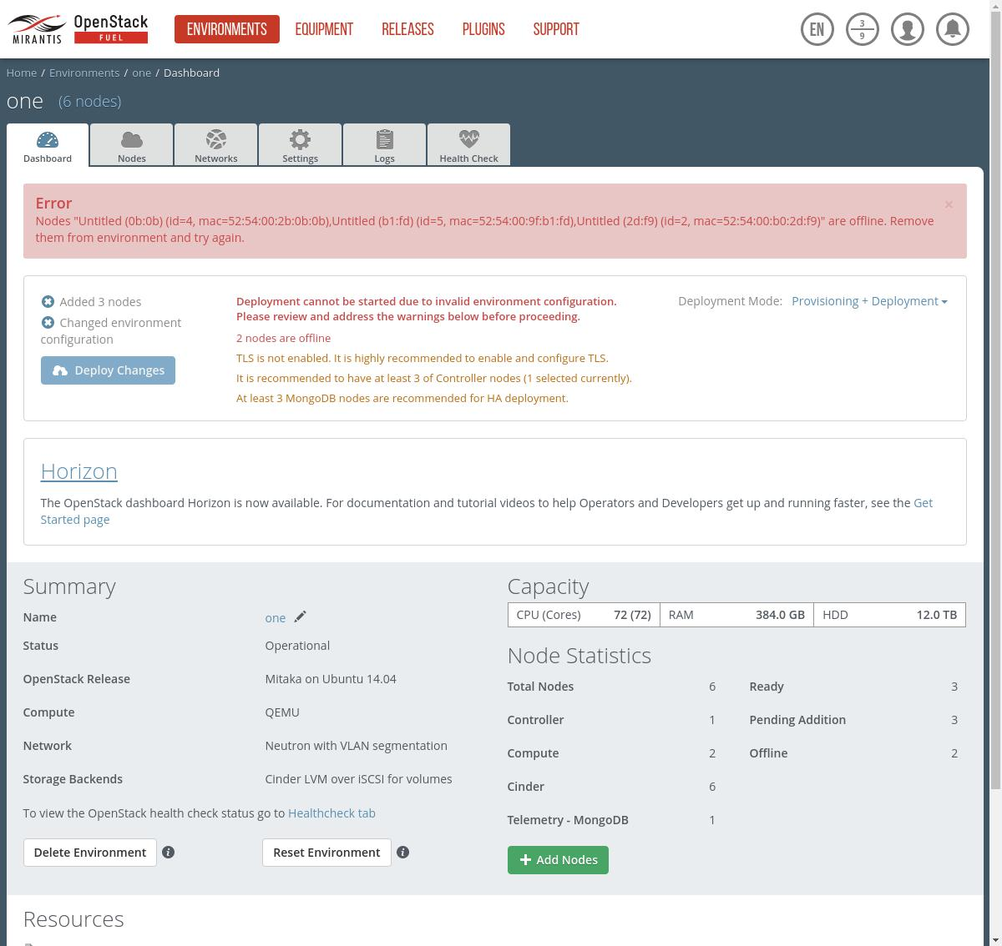

# env_1_dashboard_1

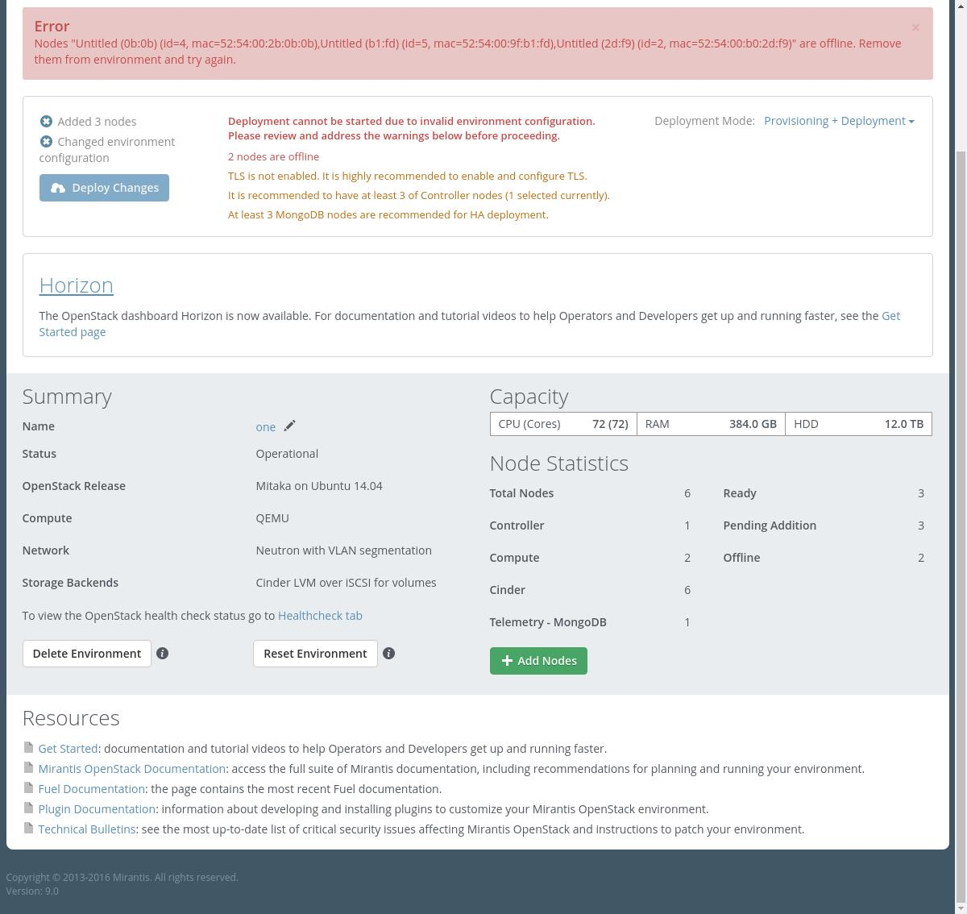

# env_1_nodes

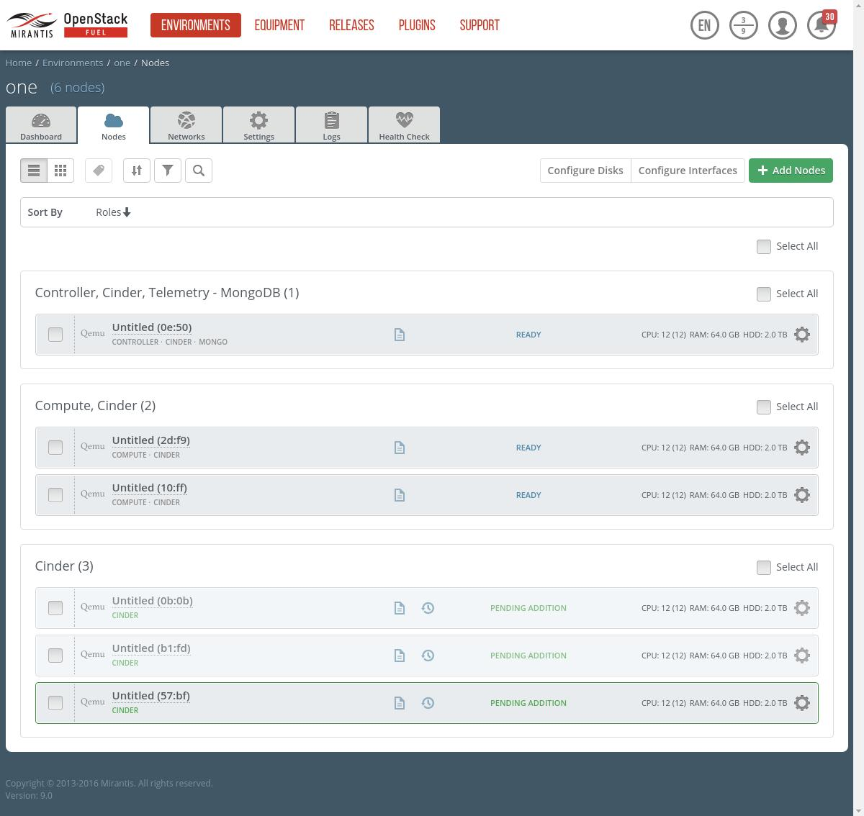

# env_1_node_1_disks

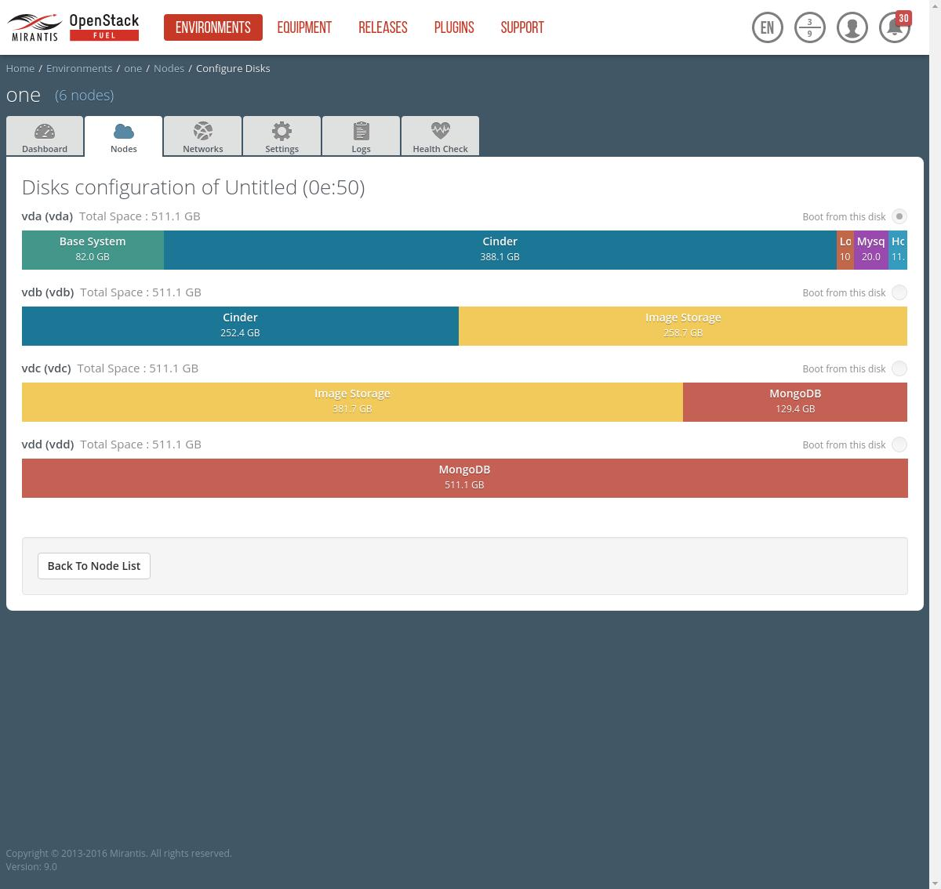

# env_1_node_1_interfaces

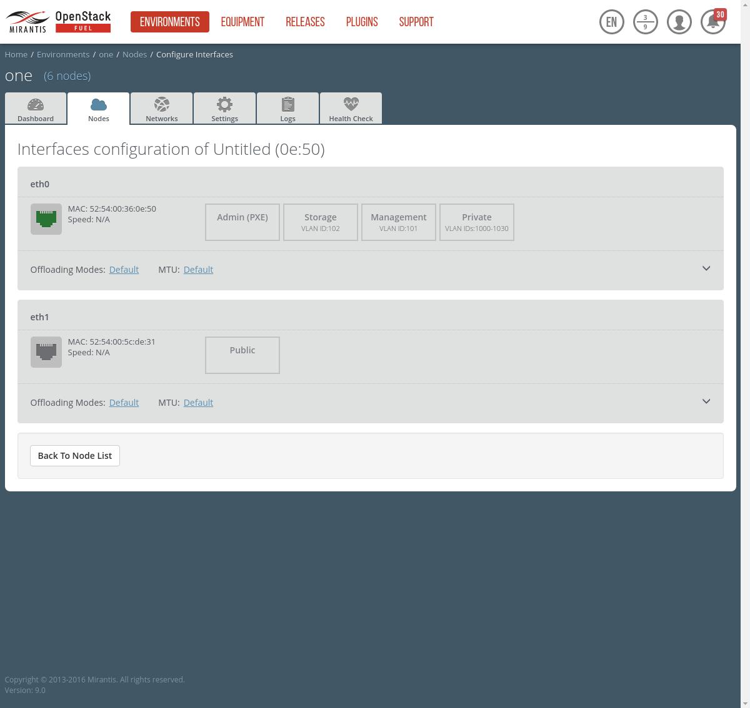

# env_1_node_2_disks

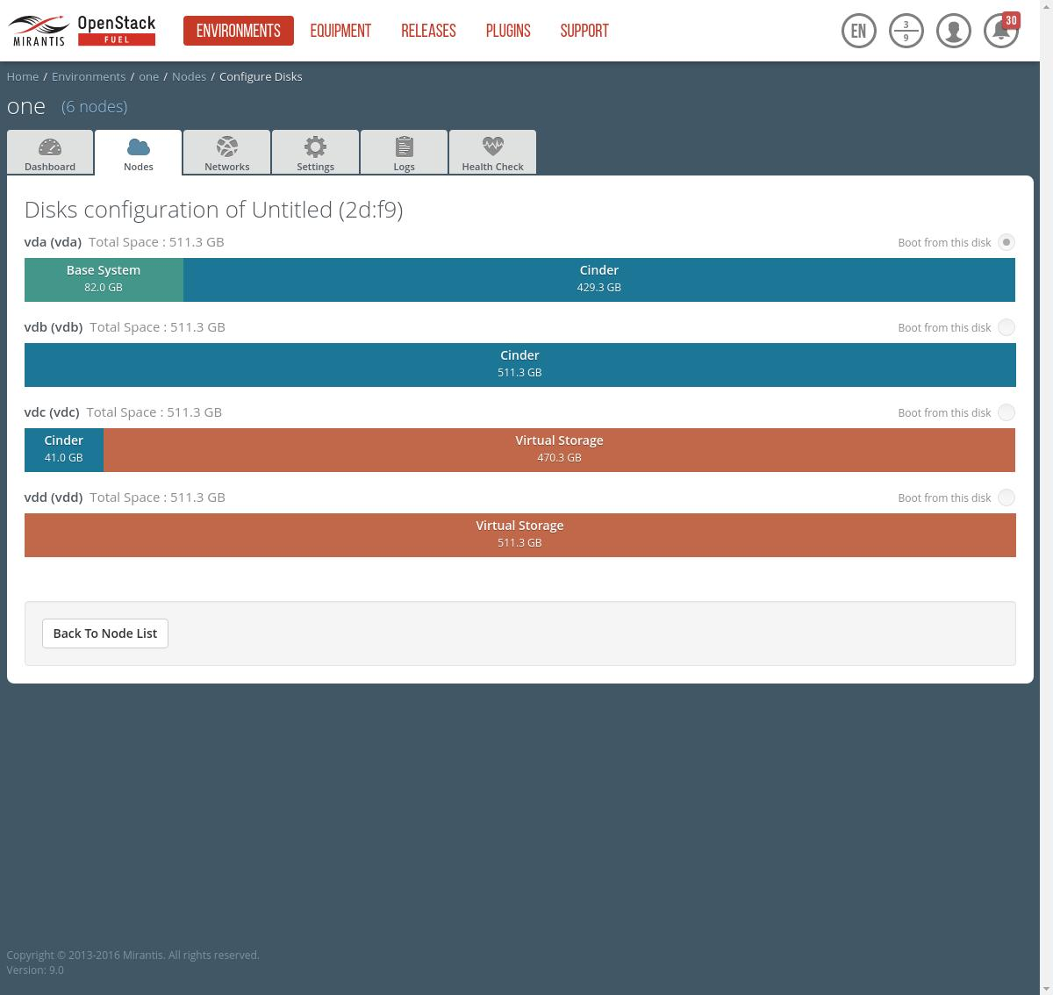

# env_1_node_2_interfaces

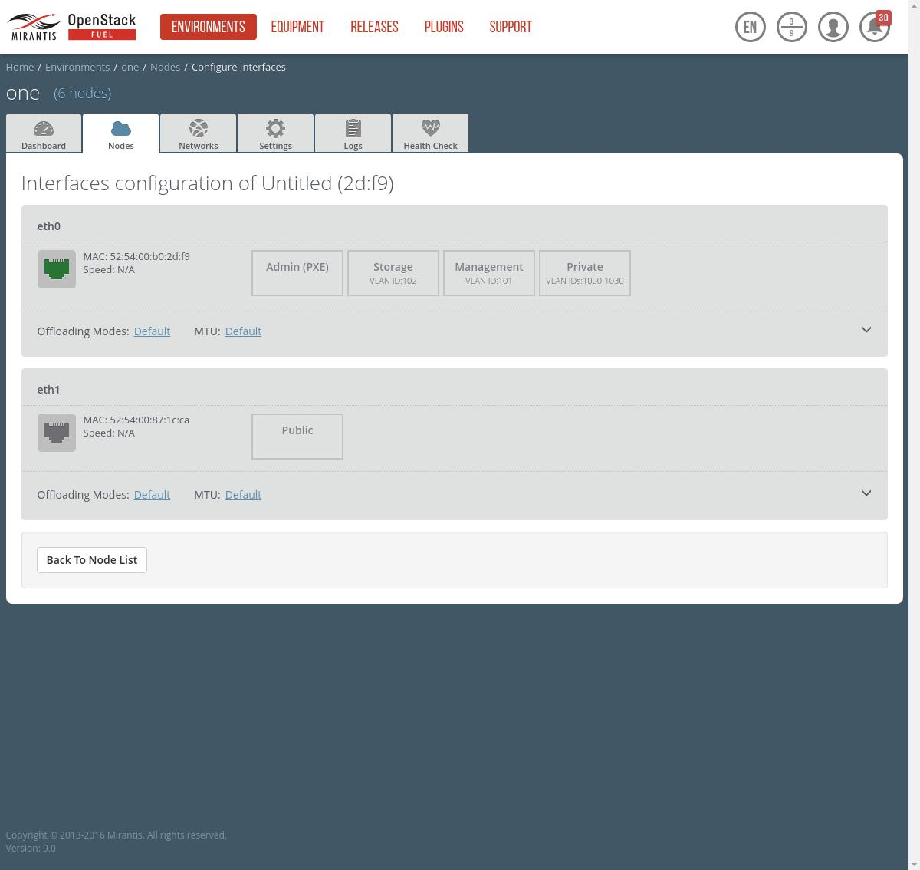

# env_1_node_3_disks

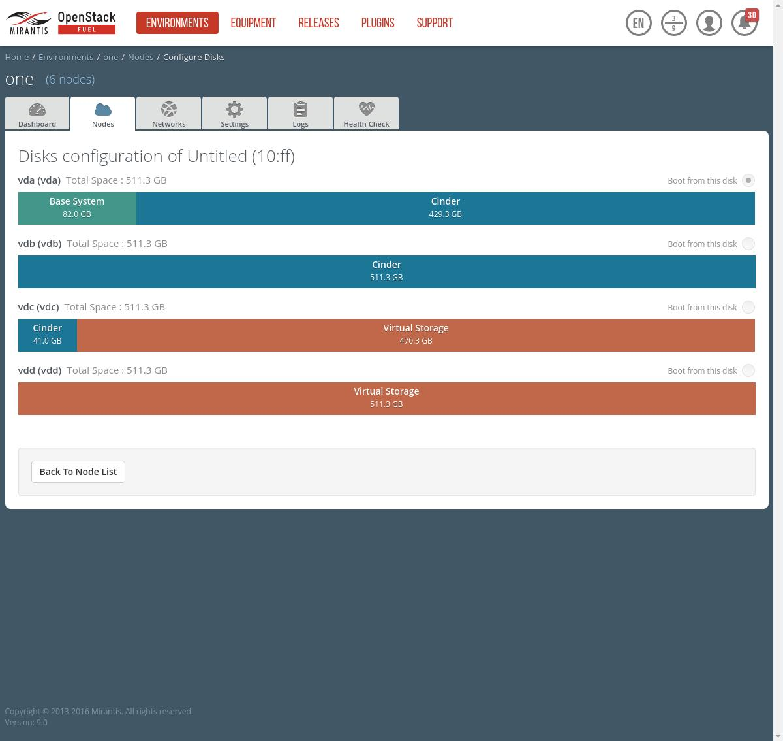

# env_1_node_3_interfaces

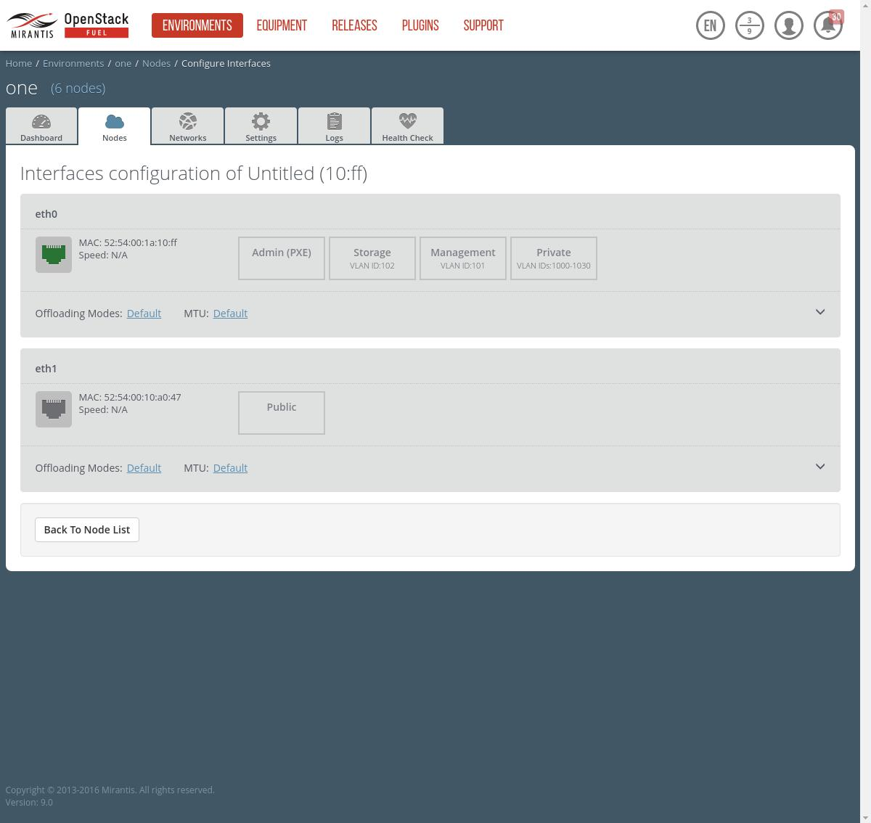

# env_1_node_4_disks

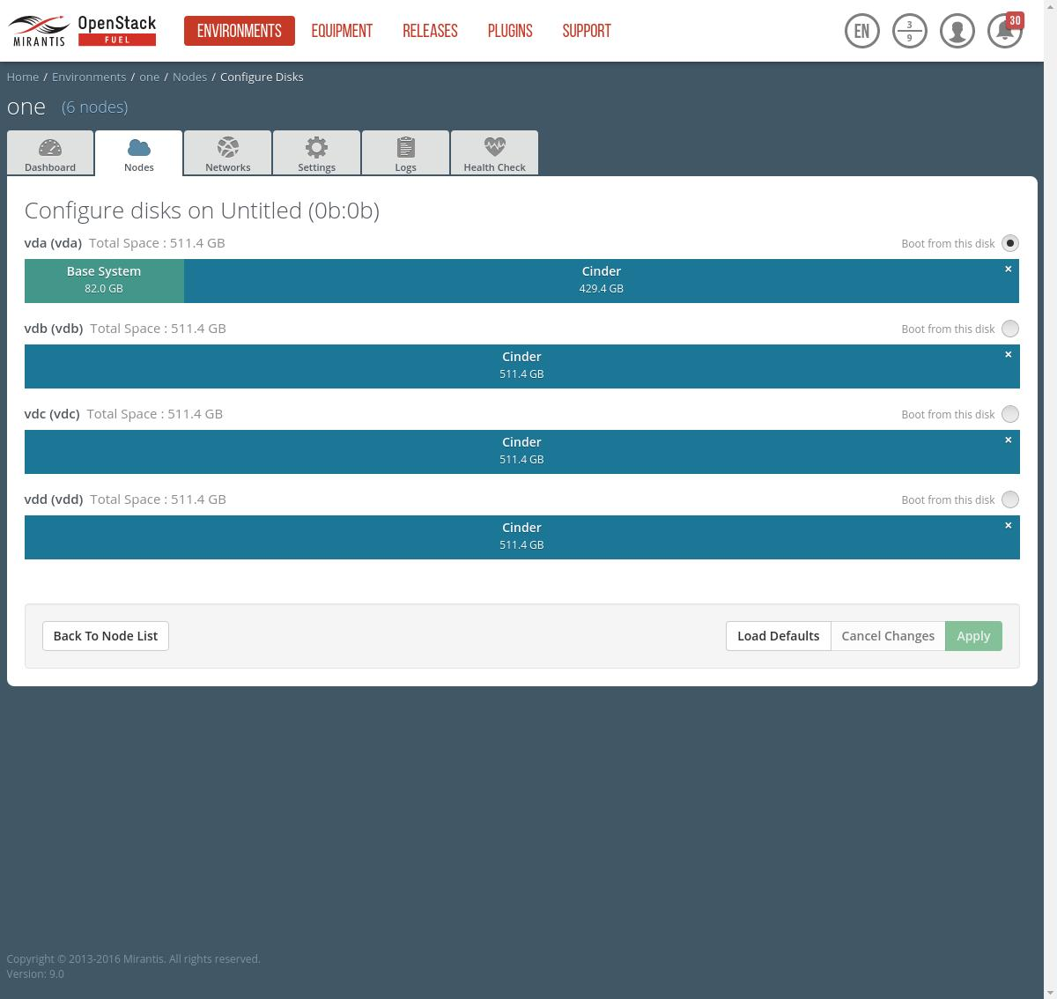

# env_1_node_4_interfaces

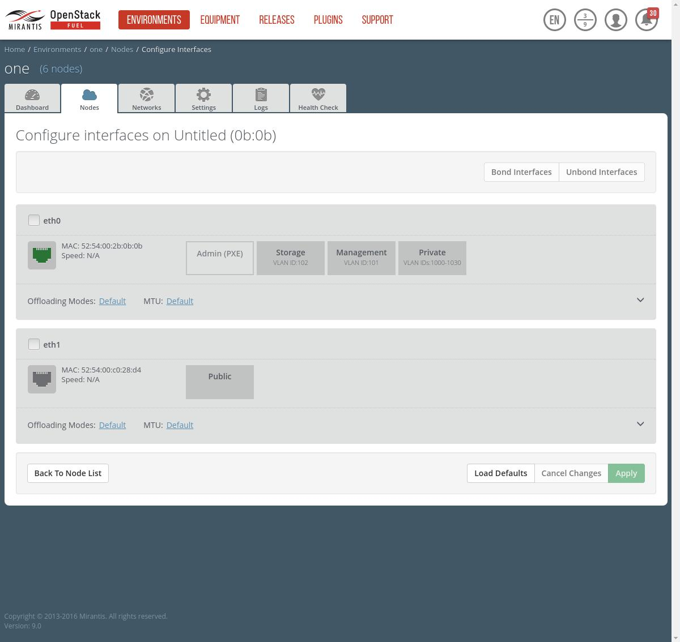

# env_1_node_5_disks

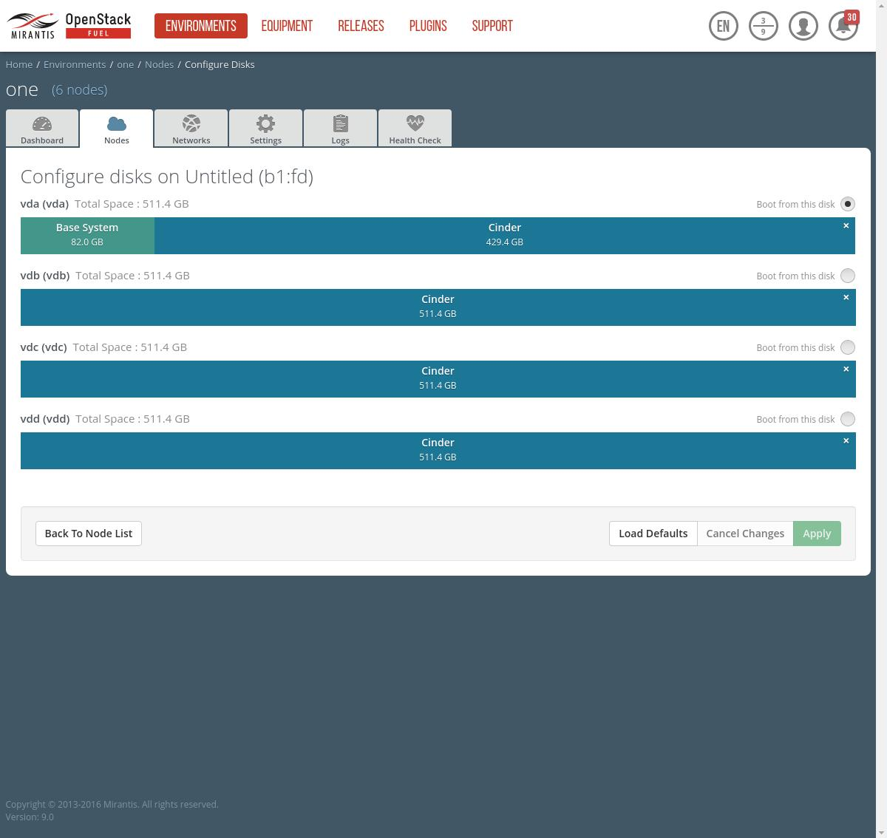

# env_1_node_5_interfaces

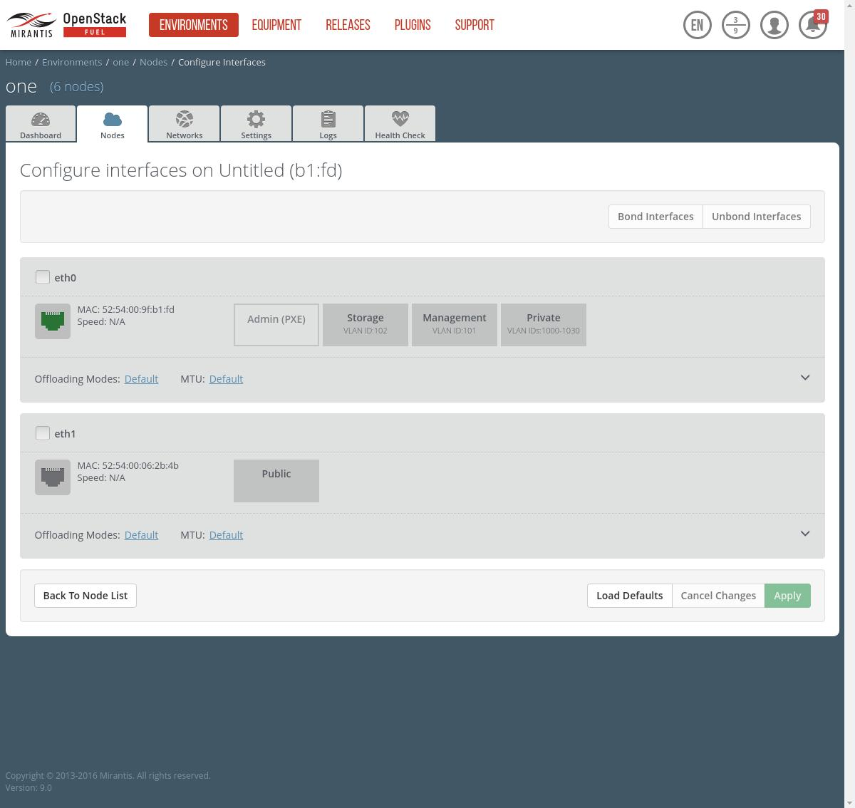

# env_1_node_6_disks_0



# env_1_node_6_disks_1



# env_1_node_6_interfaces

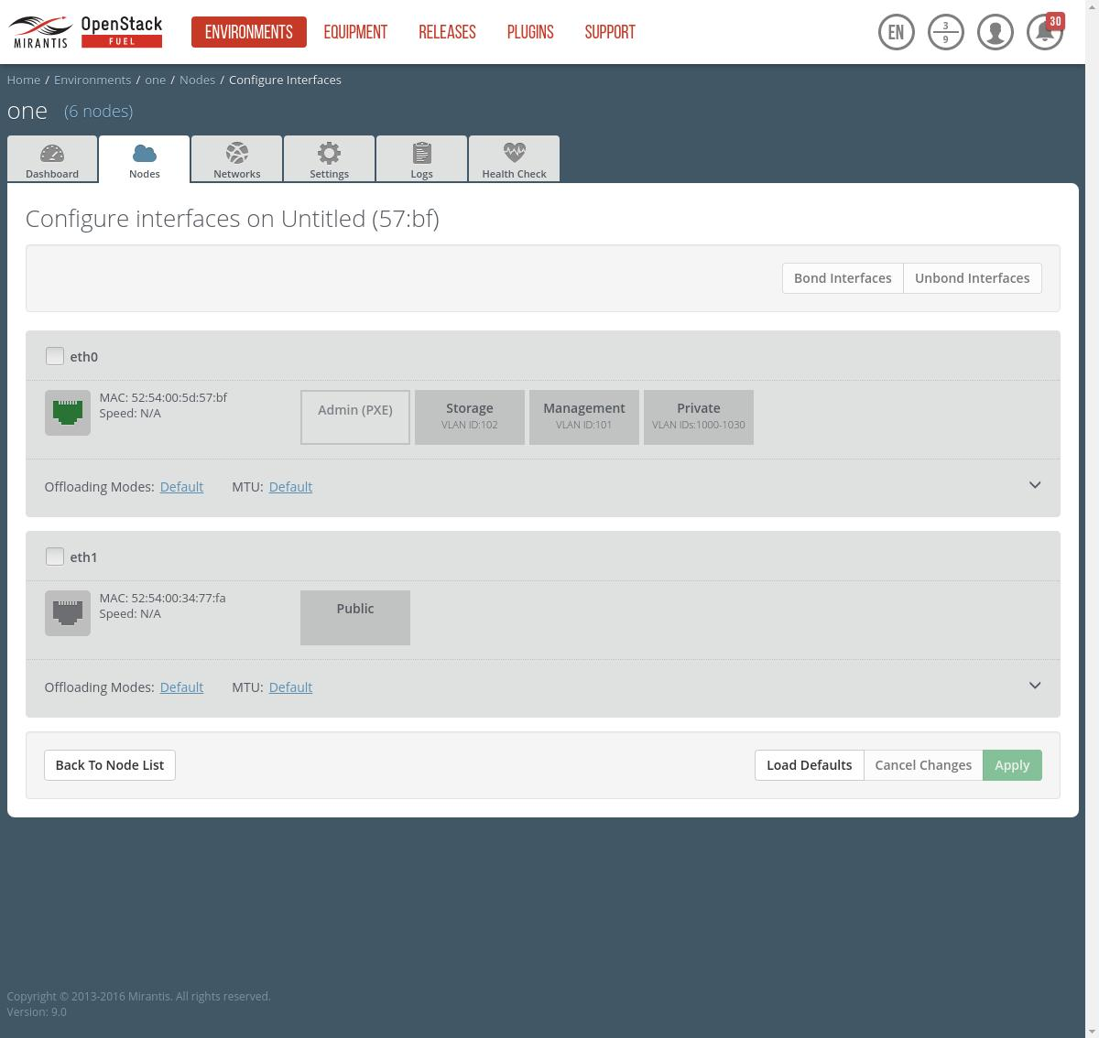

# env_1_network_neutron_l2

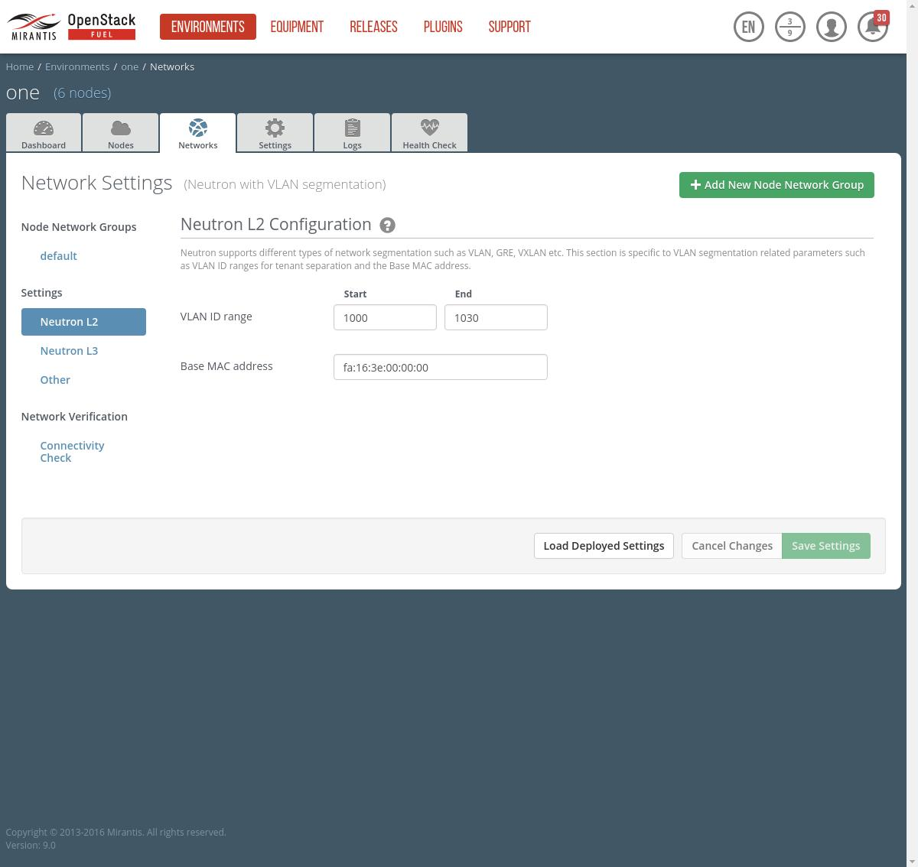

# env_1_network_neutron_l3

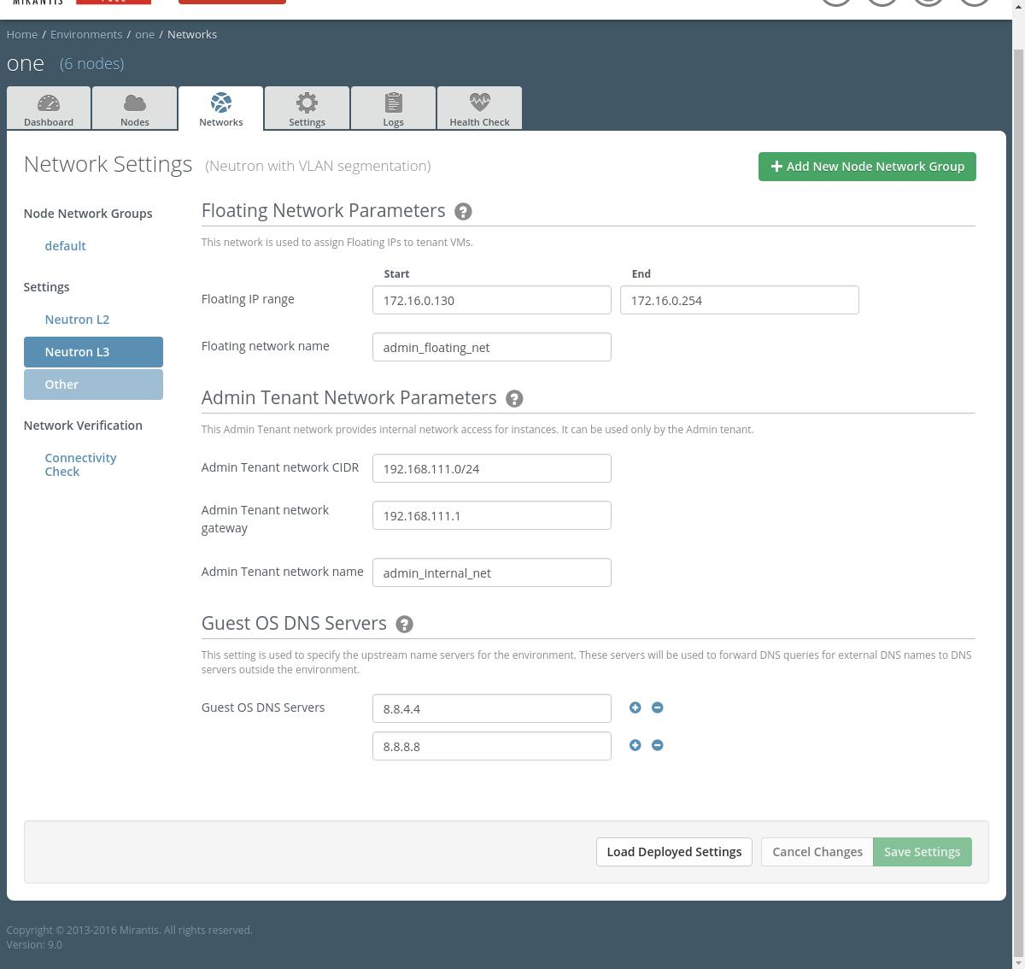

# env_1_network_other

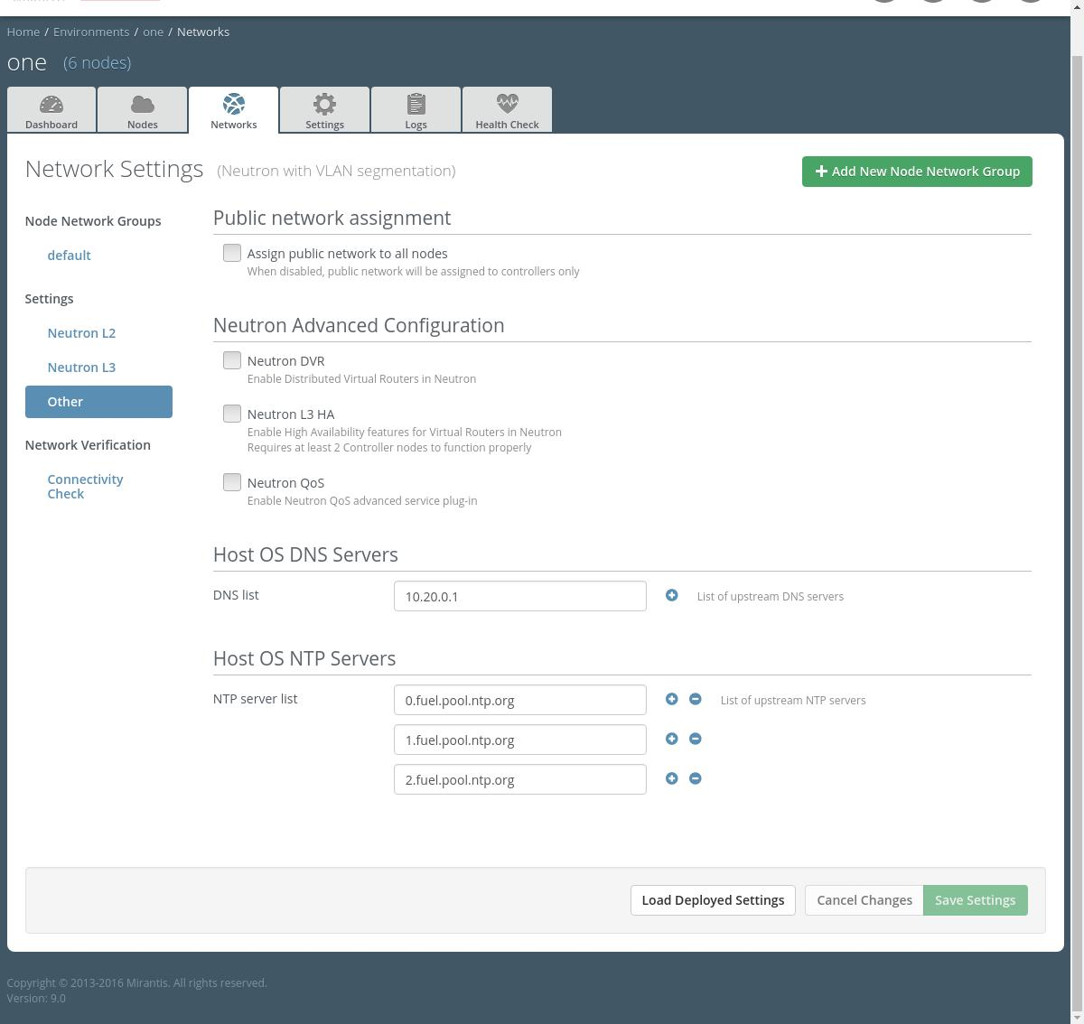

# env_1_settings_general_0

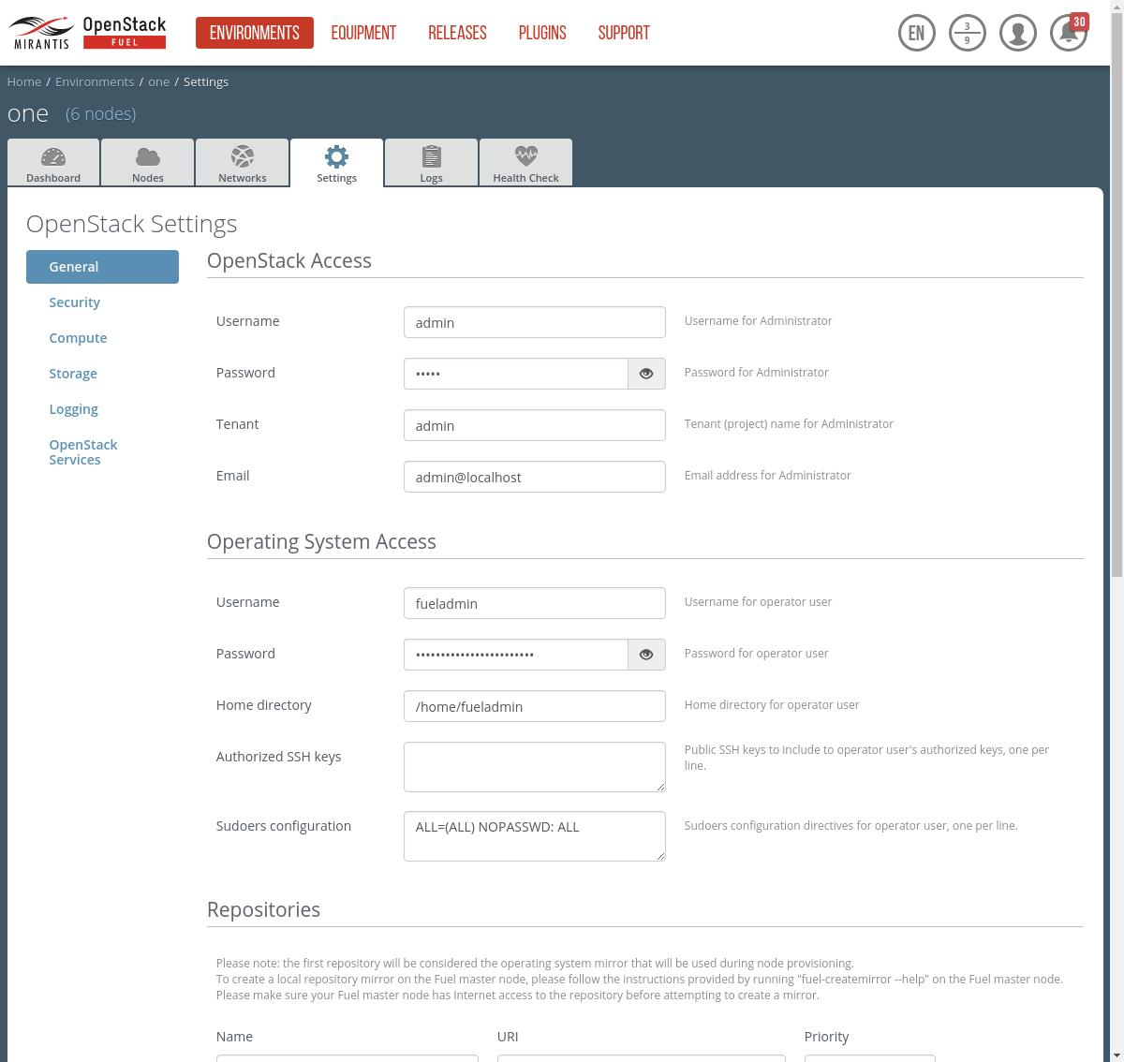

# env_1_settings_general_1

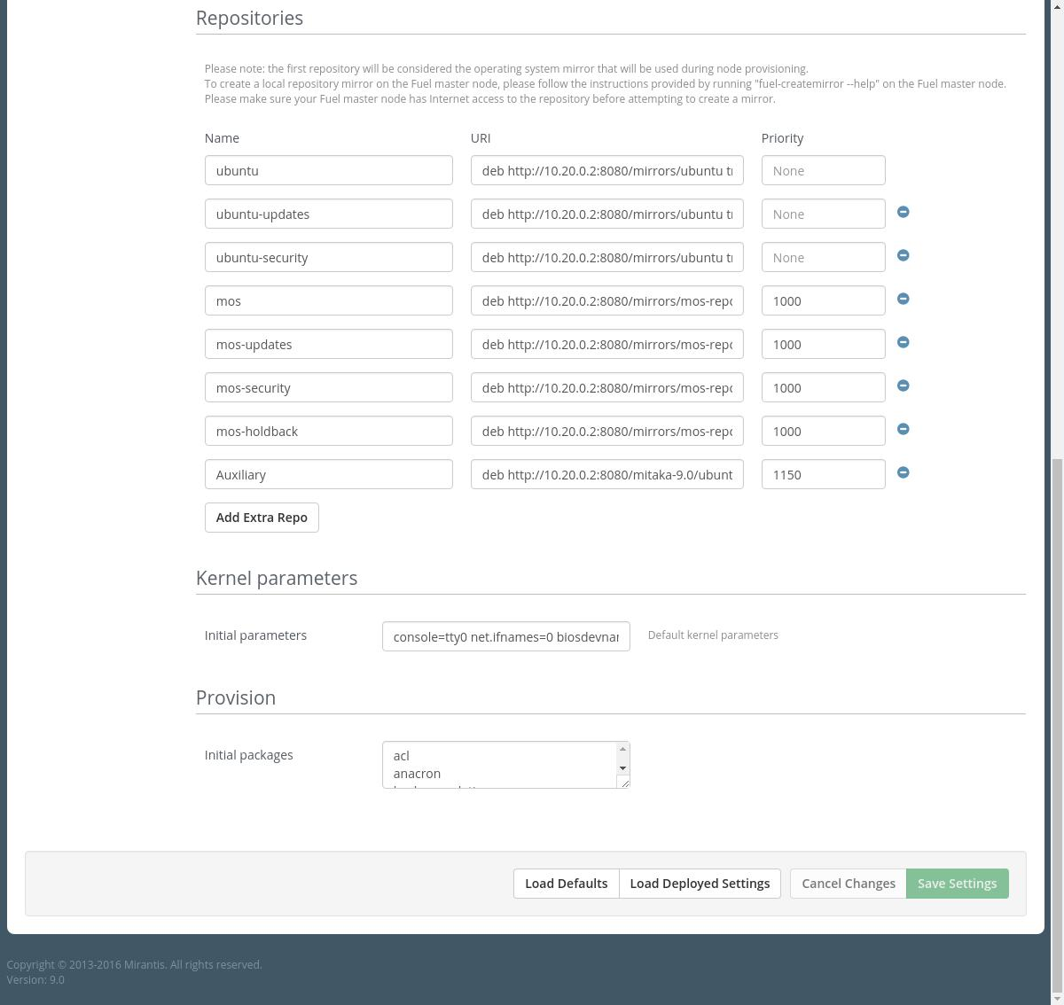

# env_1_settings_security

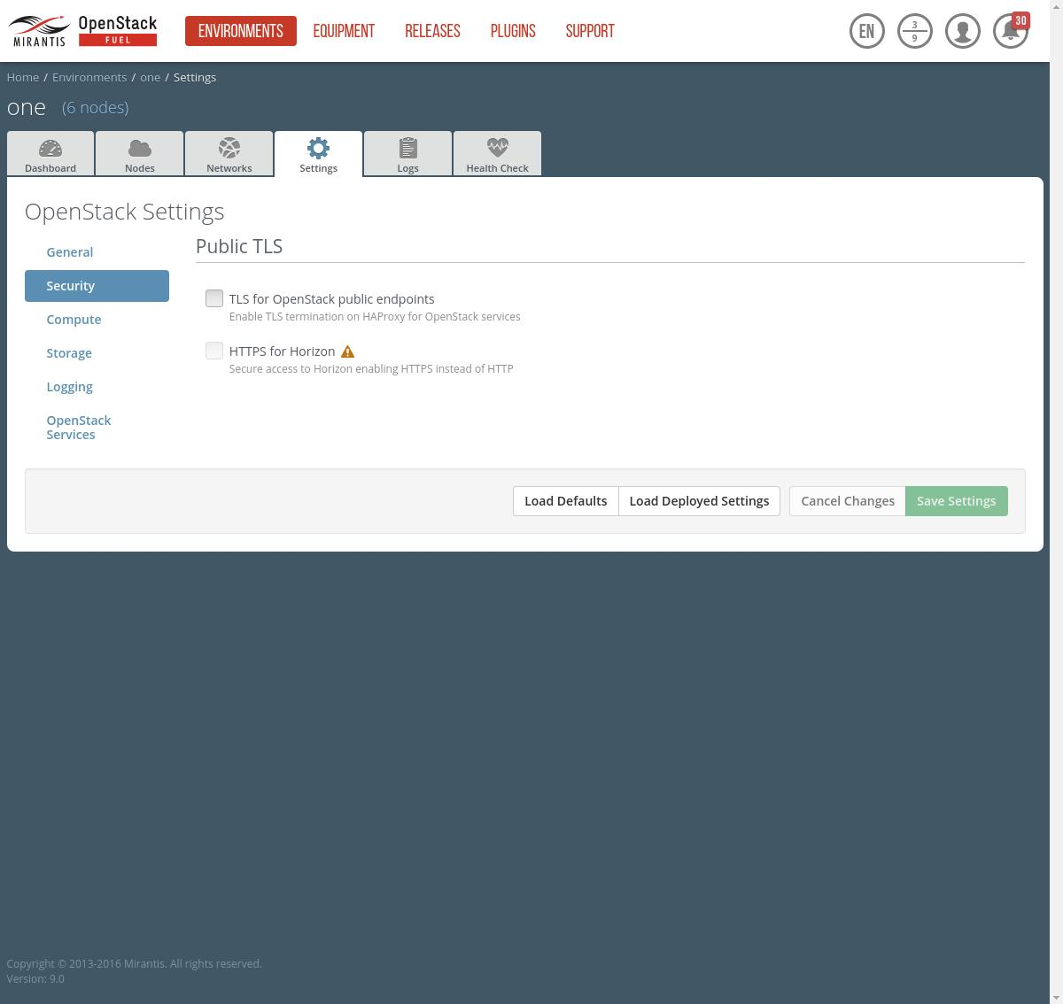

# env_1_settings_compute

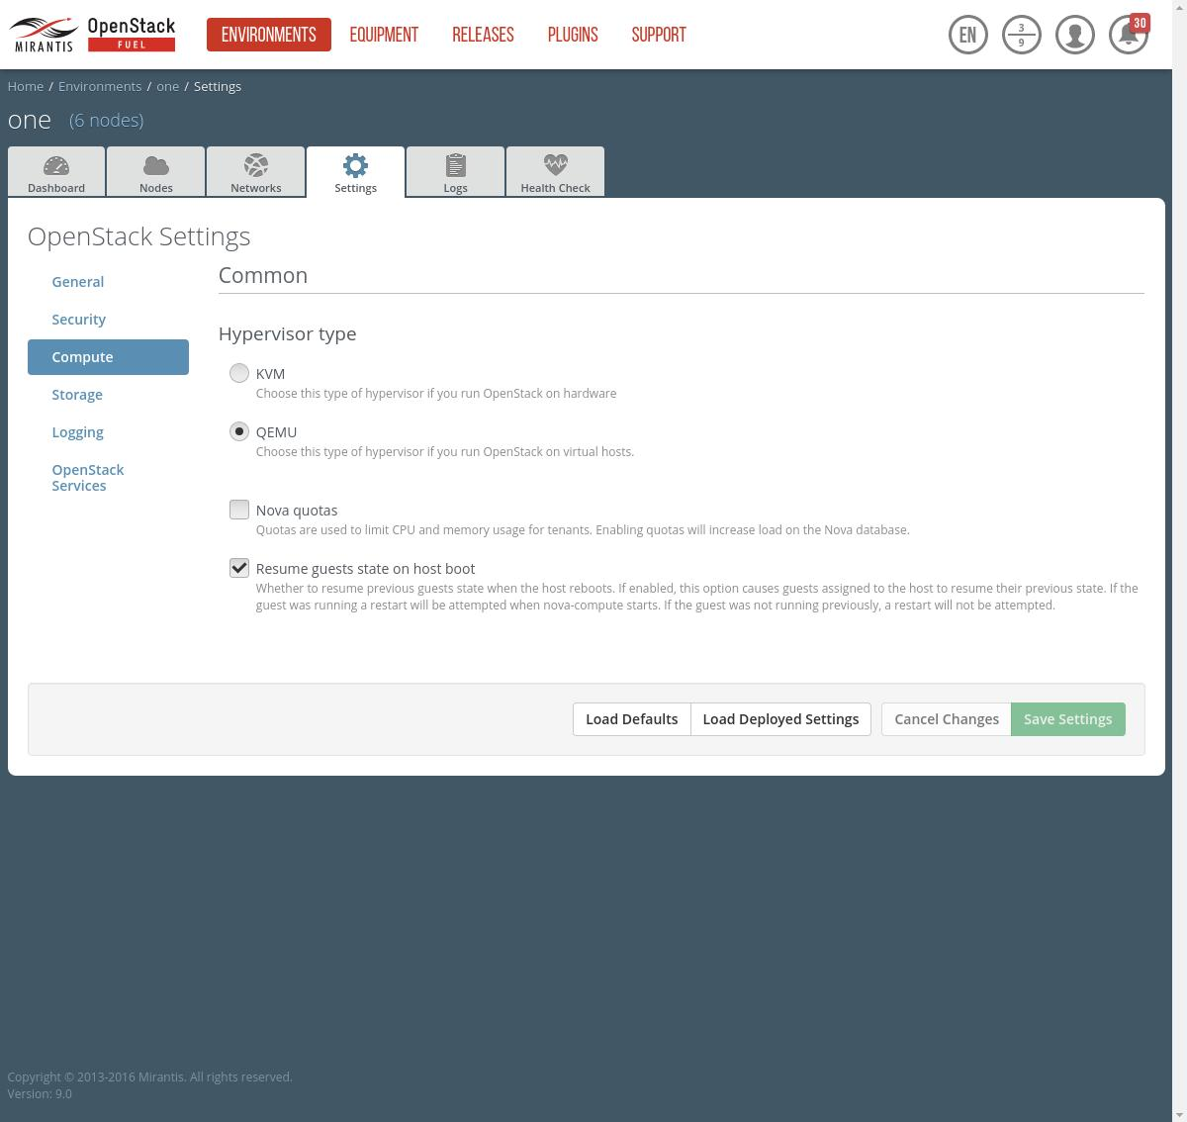

# env_1_settings_storage

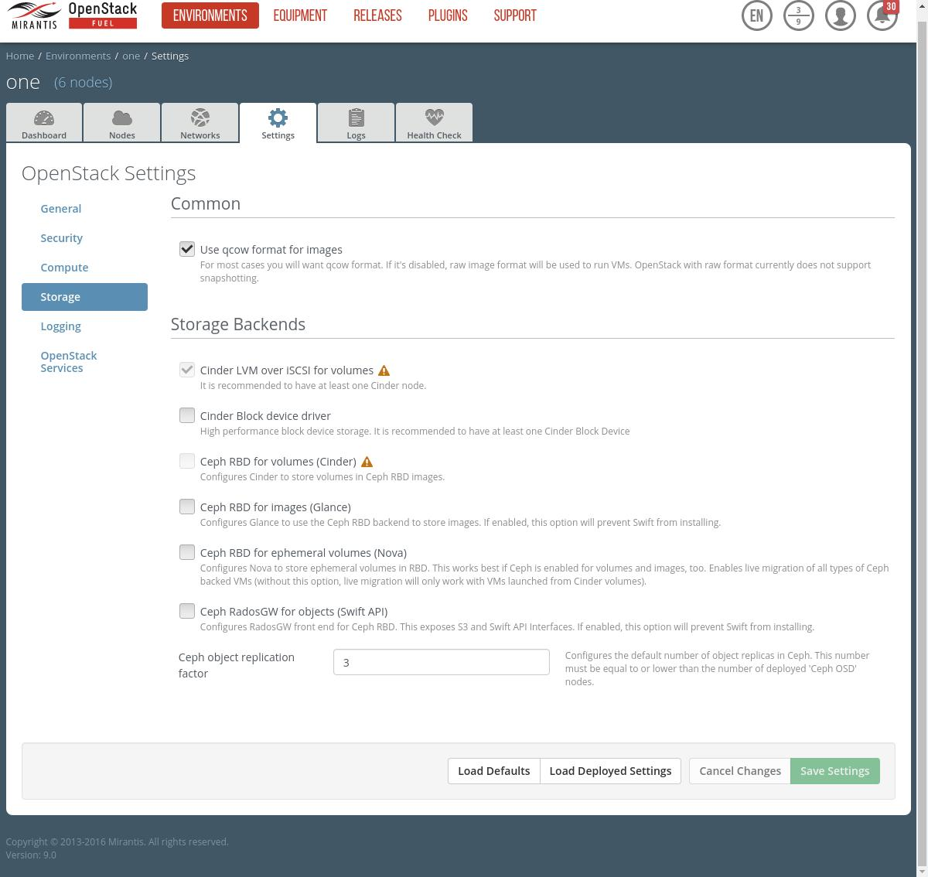

# env_1_settings_logging

